Technical part:

1. Dtml is combination of

DTML (Document Template Markup Language) is a templating facility which supports the creation of dynamic HTML and text.

1. Iframe

An inline frame is used to embed another document within the current HTML document.

1. Html links

<a href="*url*">*link text*</a>

1. Code tha ek uski output btani thi
2. Inheritance ka code tha uski b output btani thi java m tha jesy hm krty hoty thy A a = new b wagera

2 codes is trhn k thy output waly

1. Code diya hua tha or us m sy pucha hua tha overloading or overriding waly knsy functions hian
2. Iterative model m knsy step zaruri?

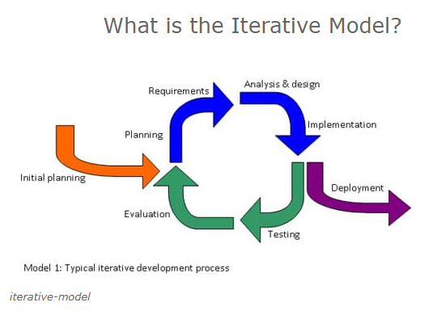

1. Software quality product
2. Sql ki queries thn unki output puchti thi outer join ki query thi
3. Normalization
4. Tree diya hua tha uska in order traversal btana tha
5. Stack push pop kr k output btani thi

Analytical part:

1. Diagrams di hui thi un m ek number missing tha wo btana tha knsa h
2. Series/sequence

English Language:

1. Paragraph read kr k questions k answer deny thy
2. Synonyms (excoriating)
3. Alternative sentence of underline sentence
4. Punctuated sentences, choose the correct one
5. Preposition